Rights Respecting Schools/Equalities Update

Anti-Racism Alliance

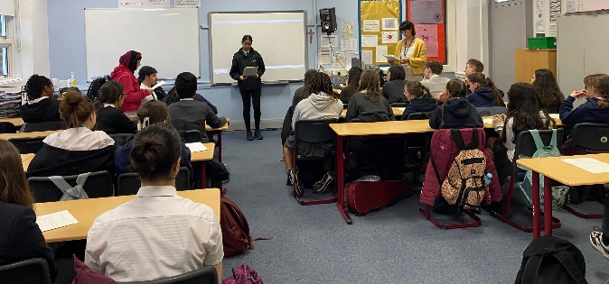

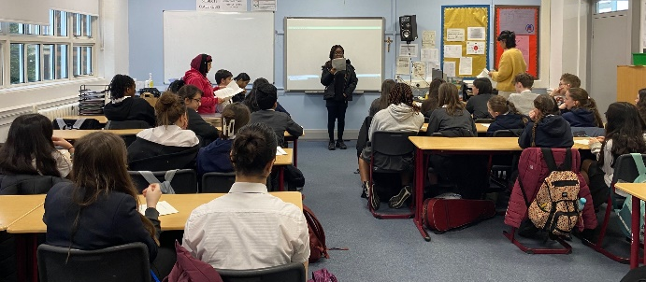
Our Anti-Racism Alliance were delighted to welcome Lochend Secondary School’s YSCA Youth Social Action group to present their inspiring work and to help us move forward with our own plans. We are determined to follow their excellent example 💪

We were delighted to welcome Emmanuel Asuquo to Holyrood for an inspiring afternoon discussing Financial literacy and making dreams a reality for all our young people 😀

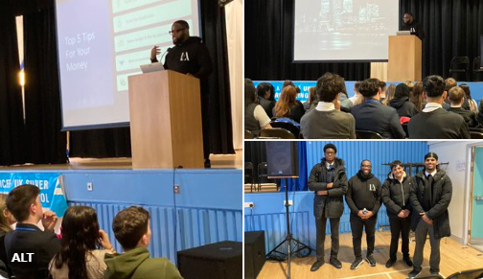

Our Roma young people have been working hard on their ‘Proud to be Roma’ documentary as well as presenting to young people, staff and local groups about their experiences.

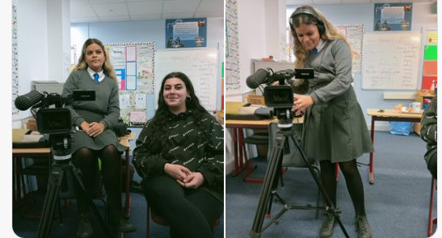

Holyrood pupils sharing how they are challenging myths about Roma people in our community.

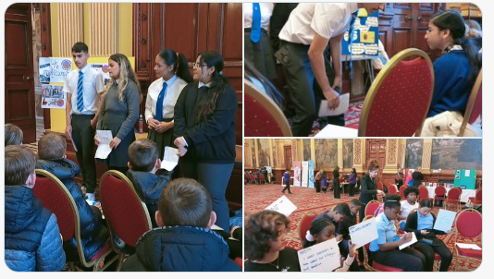

Taking part in Anti racism conversations in Glasgow City Chambers
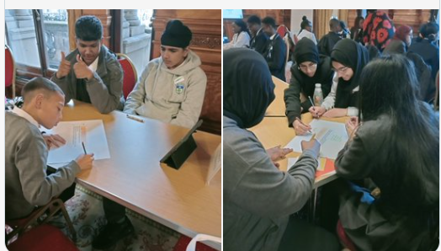

Celebrating World Hijab Day with a wonderful poster and tannoy produced by S2 pupils.
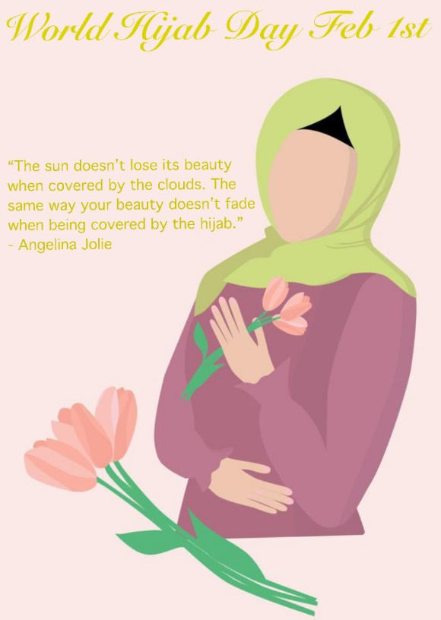
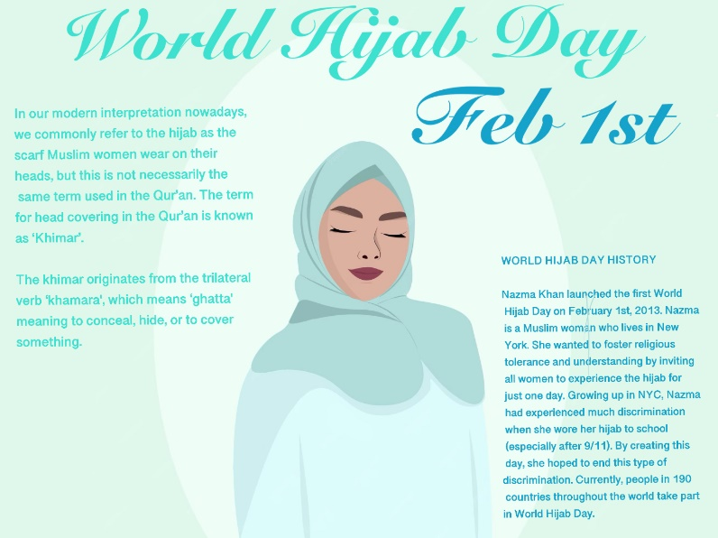

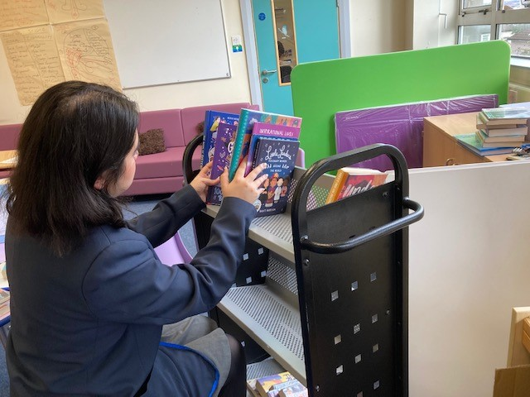
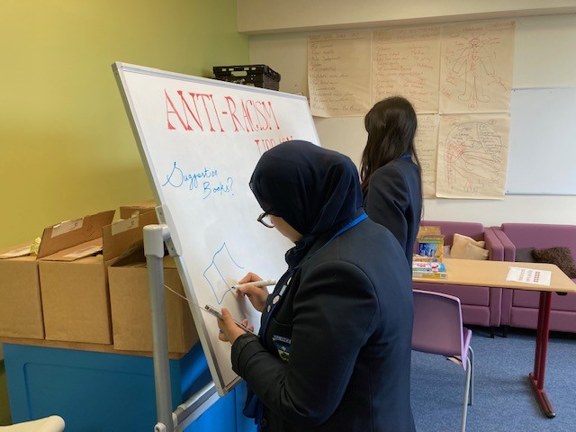
Our anti racism library is taking shape, promoting diversity in literature!
S6 Leaders selected books, decorated the whiteboard, and set up the Library in the fuel zone, during both lunchtimes.

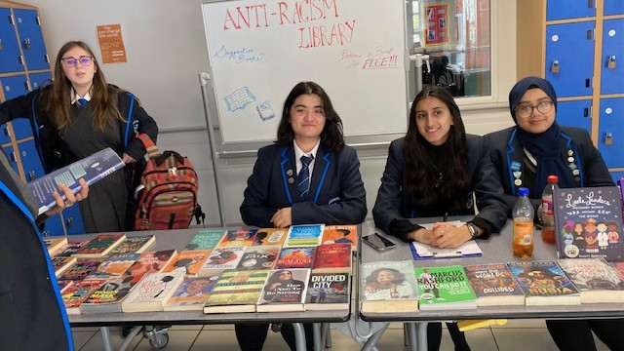
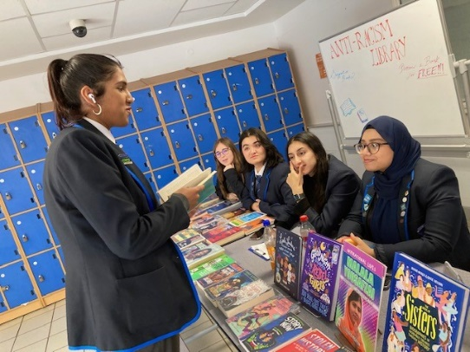

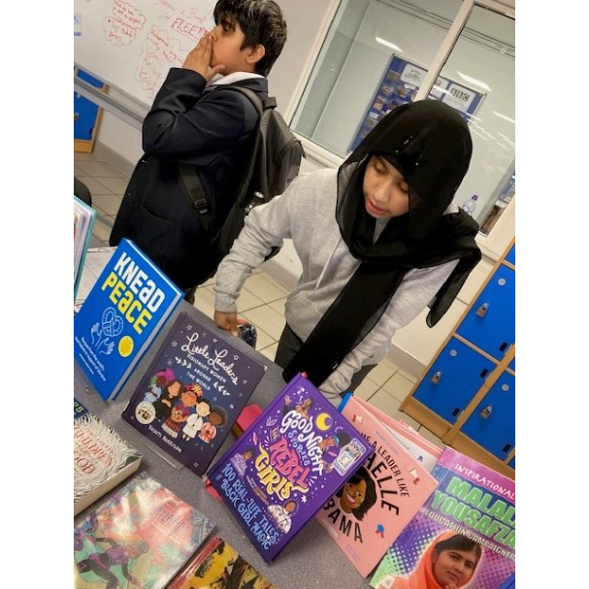
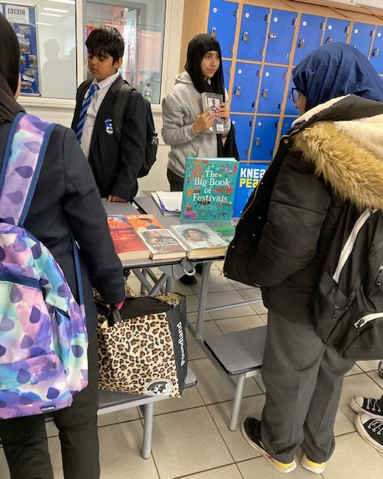
BGE helpers took over during second lunch:

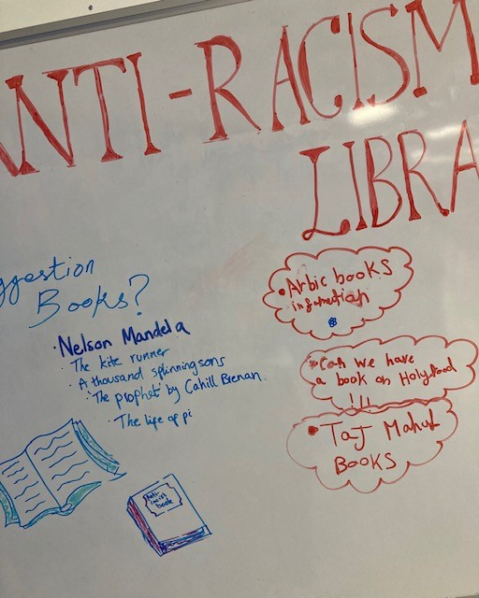
Some great suggestions on the whiteboard:
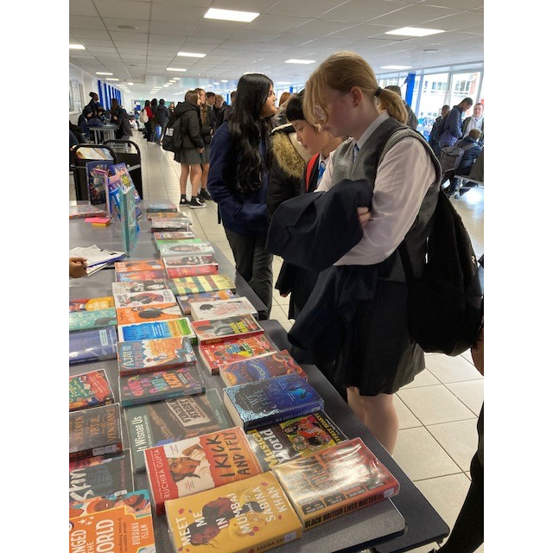

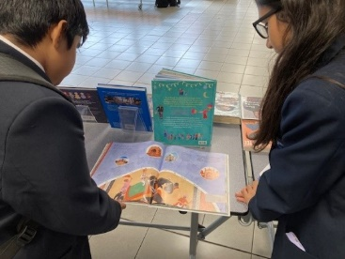
A lovely chat with S1 pupils, about their holidays to visit family in India, and trips to the Golden Temple and Taj Mahal.

Plans for future include more Anti-Racism library outreach sessions, perhaps monthly, and a Book Group for S1, depending on interest, and balance of workload with S6 exams.

It was a lovely lunchtime, and some very happy and interested young people.

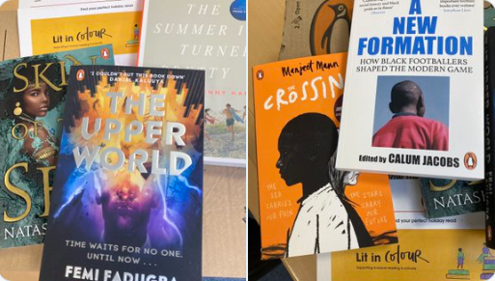
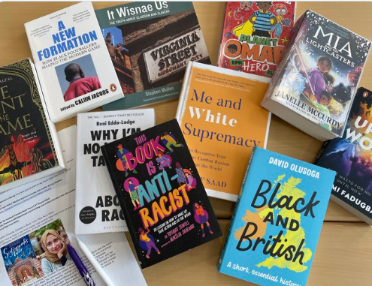

RRS

Celebrating our Silver Rights Respecting School status and making plans for our Gold application in August.

We were honoured to welcome the Children’s Commissioner for Scotland and her team to our school. Our young people thoroughly enjoyed the day and their chance to contribute to the long term plans of the Commisioner.

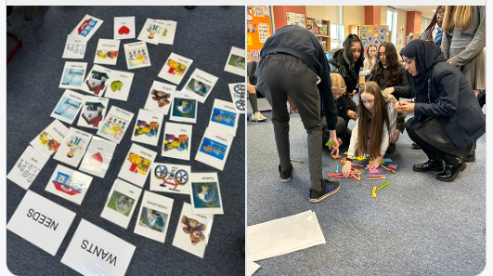

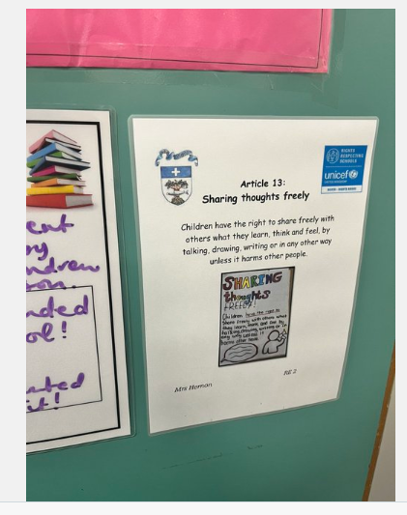
Well done to our RRS team for designing & organising displays for teachers’ adopted rights.

They have pride of place on classroom doors - so that everyone can see this is a school in which we value our rights & know how to use them! 🙌🏻
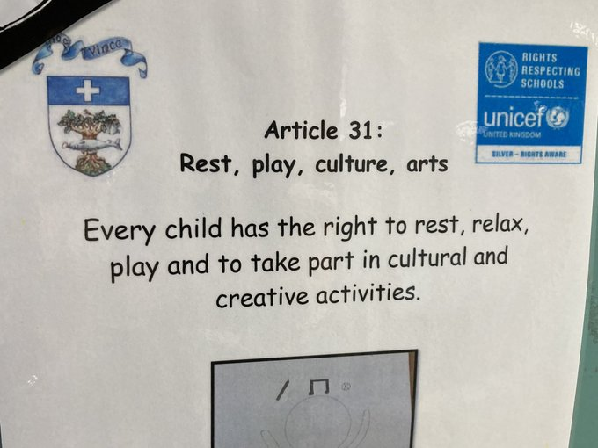

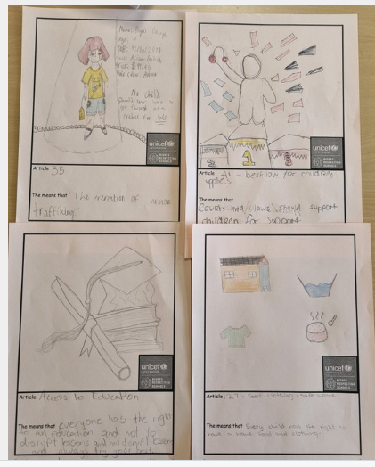
S2 Modern Studies young people have been looking at the UNCRC. They looked at the rights as well as the duties that go with them. Superb effort S2!

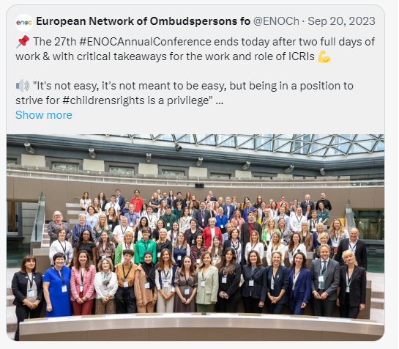

RRS member Helen in S5 represented the school at the European Netwrok of Ombudspersons Forum in Brussles. Well done Helen!

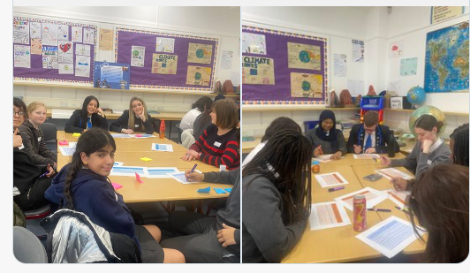
Cost of the School Day group
We were delighted to welcome the COSD National team to our school for meaningful discussions with our young people on school uniform.
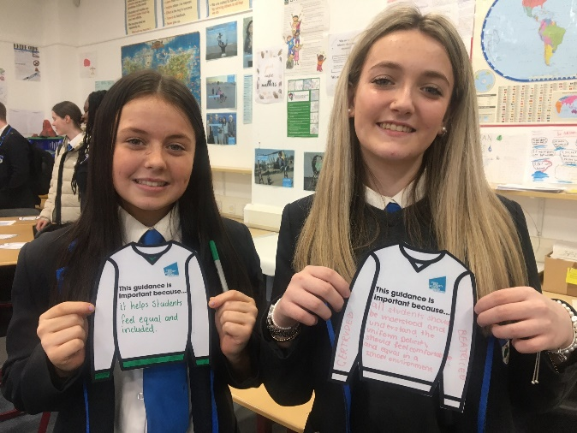
The young people enjoyed using their @HolyroodPPRs voices to influence national policy.

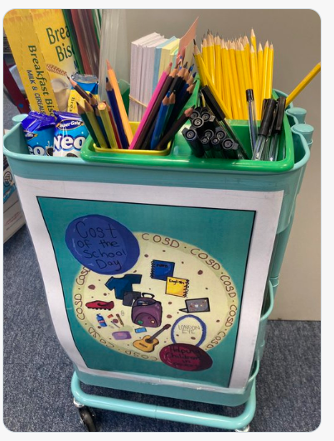
We are proud to have our trollies located around the school for anyone who needs them.

