Parent Support- Links to Study Skills
Subject | QR Code | Link
Art | 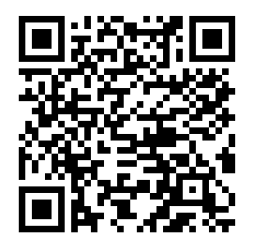 | https://sway.office.com/DjwrN1RWGOpJgzp9#content=p5132HKxy8g9OB
Biology | 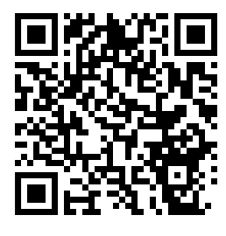 | https://sway.office.com/0JcRtGEEEuibrwef#content=yJVhUSho8ShyMV
General Information/ HFT  Practical Cookery | 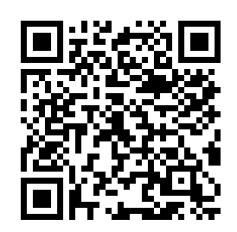 | https://sway.office.com/86fyVjBaBeeF7Gls#content=Oz9puM0ykb9DLx
Maths | 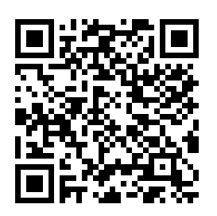 | https://sway.office.com/hOF8EKdlNbBxKADk#content=kiXFfl453xvEWe
Physics | 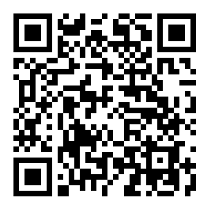 | https://sway.office.com/CJBPf9EKu3WLOZ7I#content=n5KhsCtFQFQvrd
Business Education | Higher Accounting https://sway.office.com/rksr4v5Rstngyu2K?ref=Link  Higher Administration & IT https://sway.office.com/CvPNRd7EEhyXXdZs?ref=Link  Higher Administration & IT (Theory) https://sway.office.com/l5U18XwGA5LuIkpf?ref=Link  Higher business Management https://sway.office.com/RKzwg0PZJONxk5TC?ref=Link  National 5 Accounting https://sway.office.com/GA5y9F3CXP6rG8DA?ref=Link

